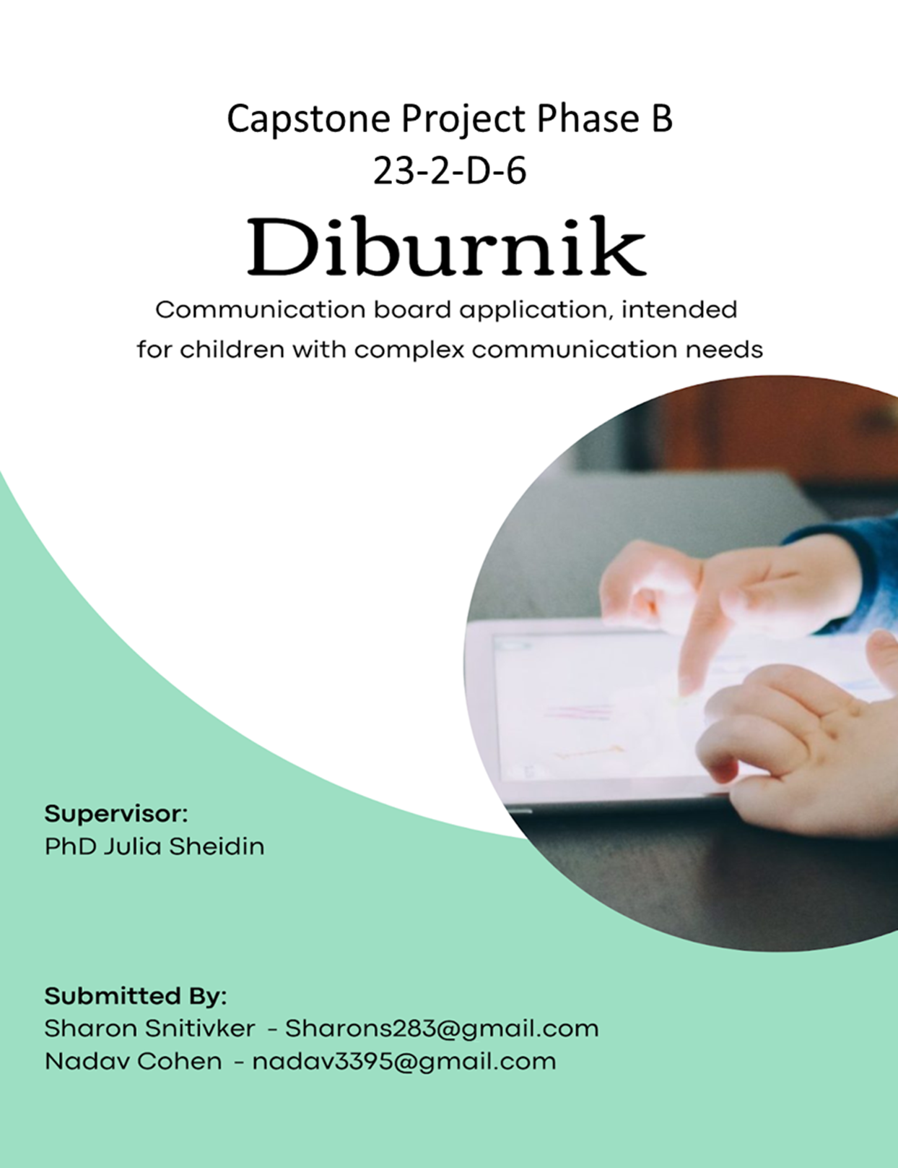

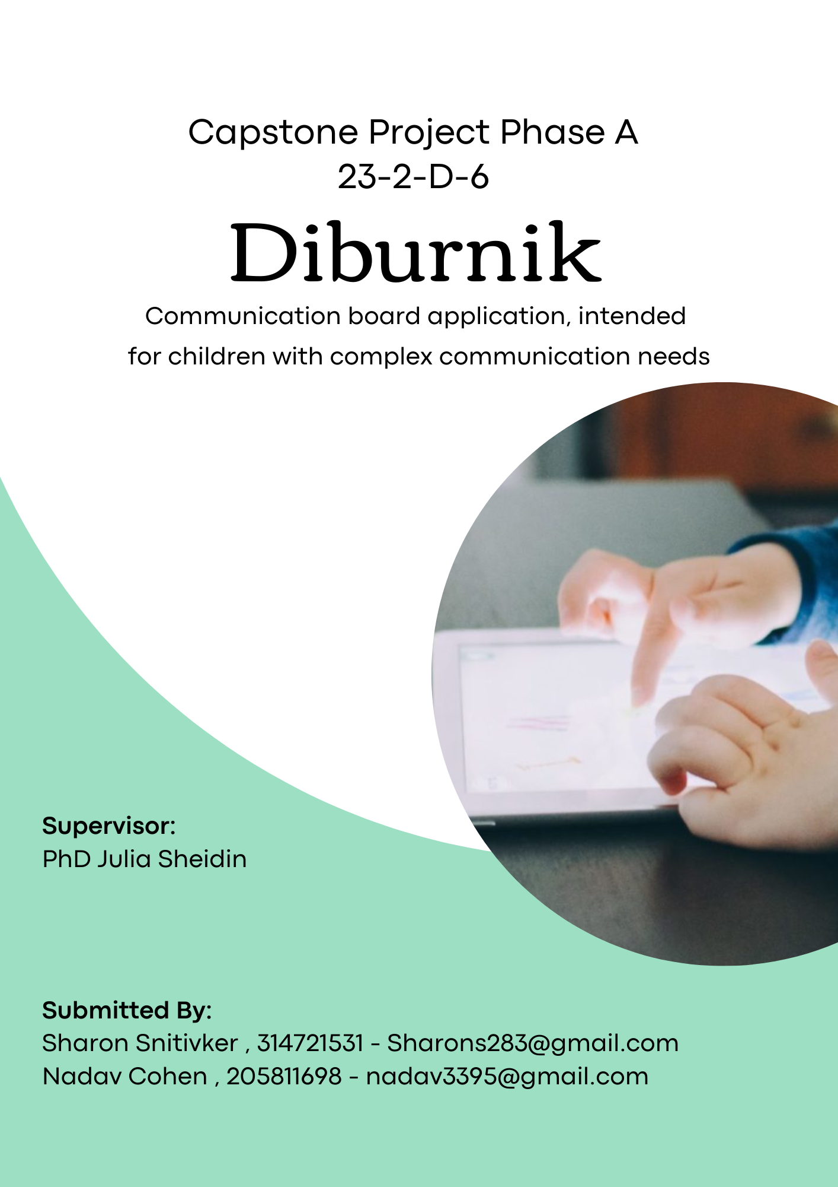

**Table of Contents**

1. **Abstract** 3

2. **General Description** 4

2.1. **Children with Complex Communication Needs** 4

2.2. **Alternative Communication Tools** 4

2.3. **Colorful Semantics (CS)** 5

3. **Solution Description** 7

3.1. **Package Diagram** 7

3.2 **Activity Diagram** 8

4. **Description of the Development Process** 9

5. **Challenges Faced and Solutions** 13

5.1. **Planning and Functional Challenges** 13

5.2. **Aesthetics and Design Challenges** 16

6. **Results and Conclusions** 17

6.1. **Goals Achievements** 17

6.2. **Conclusion** 18

6.3. **Future Work** 19

7. **User Documentation** 20

7.1. **User Guide** 20

7.1.1. **General Description** 20

7.1.2. **Operating Instructions** 21

7.2. **Maintenance Guide** 34

7.2.1. **Application Maintenance Guide** 34

7.2.2. **Database Structure** 35

7.2.3. **Use Case Diagram** 38

8. **References** 39

9. **Appendixes** 40

# 1. Abstract

People experience communication difficulties for a range of reasons, including learning/intellectual disabilities, autism spectrum disorder (ASD), brain injuries, cerebral palsy and motor neuron disease. Digital solutions, such as communication boards, have been proven helpful in getting the message from those unable to speak or even write through conventional methods. However, most commercial digital boards are simply unaffordable for most families.

While Augmentative and Alternative Communication (AAC) has been widely studied and utilized for individuals of all ages, in our project we primarily focused on children. We aimed to develop an improved AAC Board application, that will combine a set of unique features in order to best fit the needs of children with complex communication needs (CCN), designed to be used on both tablet and phone devices, supporting both iOS and Android platforms.

Our main project goal is to help children with different levels of CCN to enhance their communication and language (Hebrew) abilities. We aim to do so by empowering the frequency in which they will independently initiate requests to express their desires, needs and feelings using our application. Furthermore, our application not only serves as a standard communication board but also functions as an educational platform that enables each child to practice and develop their language and communication skills

**Keywords**: Complex Communication Needs (CCN), Augmentative and Alternative Communication (AAC), Communication Board, Educational Platform, Children.

# 

# 2. General Description

# 2.1. Children with Complex Communication Needs

Many children with complex communication needs (CCN) resulting from a wide range of developmental disabilities such as: autism spectrum disorders, cerebral palsy, down syndrome, and other special needs often do not develop speech and language skills as expected [2]. Their speech abilities may be limited, they might experience delayed speech development or have speech that is difficult to understand. These communication challenges can result in them being severely restricted in their ability to communicate effectively with others, making their needs and wants known, expanding their cognitive skills, and developing the foundations for later language and literacy skills.

# 2.2. Alternative Communication Tools

Communication boards are a distinct category within the broader field of Augmentative and Alternative Communication (AAC) [1] tools, encompassing a range of both low-tech and high-tech variants. Low-tech communication boards offer non-electronic communication methods and typically involve the use of physical boards or books containing symbols, pictures, or words that can be pointed to or selected by the user. On the other hand, high-tech communication boards employ computer-based solutions that effectively function as the user's "voice" by generating digitized, synthesized, or recorded speech in response to the user's input.

Extensive research provides compelling evidence that children with complex communication needs (CCN) experience significant advantages in their communication, language, and literacy skills through the use of augmentative and alternative communication (AAC). Importantly, AAC interventions carry no risks for their speech development.[3]

The currently available communication boards for children with CCN often lack support for the Hebrew language, and some applications are exclusive to either Android or iOS devices, limiting their availability. Another significant disadvantage is the exorbitant costs associated with these applications, making them unaffordable for certain individuals and their families. Additionally, many existing systems only support a single user on the same device, restricting the ability for multiple users to utilize the same device effectively. Our communication board application aims to stand out from the current market solutions by offering a unique combination of features.

Our system is dedicated to fostering the independent communication abilities of children with CCN, aiming to make a significant and time lasting impact on their overall development. Beyond merely facilitating communication, our system is designed to empower these children, providing them with tools to interact effectively with their environment and express themselves independently.

To ensure usability for our target audience, we planned a user-friendly interface characterized by simplicity and minimalism. By limiting the number of screens and avoiding unnecessary complexity, we prioritize ease of use without compromising the essential functionalities required for effective communication support.

Our system incorporates profile management functionality, allowing each child to create and access their personalized communication boards from any device. This feature not only enhances convenience but also promotes consistency and familiarity in the child's communication experience across different contexts and settings.

By catering specifically to the needs of children with CCN and leveraging innovative design principles, our system endeavors to serve as a valuable tool in their journey towards improved communication skills and holistic development.

# 2.3. Colorful Semantics (CS)

**Colorful Semantics (CS)** (see Figure 2): The initial aim of CS approach was to serve as a therapeutic tool to help children with CCN to understand and construct sentences through a semantic script that refers to syntactic structures.

This method can be helpful in supporting children with a limited vocabulary to organize the grammatical content of their sentences CS’s semantic script consists of a system of colors associated with questions (e.g., Who?, What Doing?, What?) that helps children understand the semantic role of each sentence’s element.

The main advantage of CS is identifying the semantic roles of each constituent of a sentence. That is, identifying the function performed by a word concerning the predicate it modifies.

Figure 2. Illustrates the four basic semantic roles of CS:

(1) Agent (2) Verb(3) Theme and (4) Location.

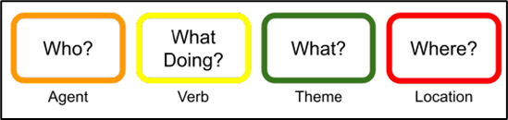

*Figure 2: Colorful Semantics.*

These roles are associated with colors in order to:

1) Make a visual distinction between each semantic role.

2) Enhance the relationship between the question and the semantic role

3) Associate each type of phrase with a visual sequence of colors

4) Alert the child when he omits a semantic role

Colors act as a visual aid to indicate the grammatical structure of a sentence, and questions help to link this structure (syntactic) to its meaning (semantics).

Semantic roles are more significant for individuals with CCN than syntactic functions (i.e., subject, verb, and object).

Its usage is what differentiates CS from other color-coding systems in which the colors refer to grammatical classes (e.g., nouns, verbs, or adjectives).

# 3. Solution Description

### 3.1. Package Diagram

The following diagram shows the three main components of our system:

1. **Application (Client):** responsible for handling the logic and functionality of your system that directly interacts with users or clients.
2. **Server:** hosts and manages the application logic, providing services and resources to clients or users. It handles tasks such as processing requests from clients, managing sessions, and delivering data or content.
3. **Database:** stores and manages the data used by the application.

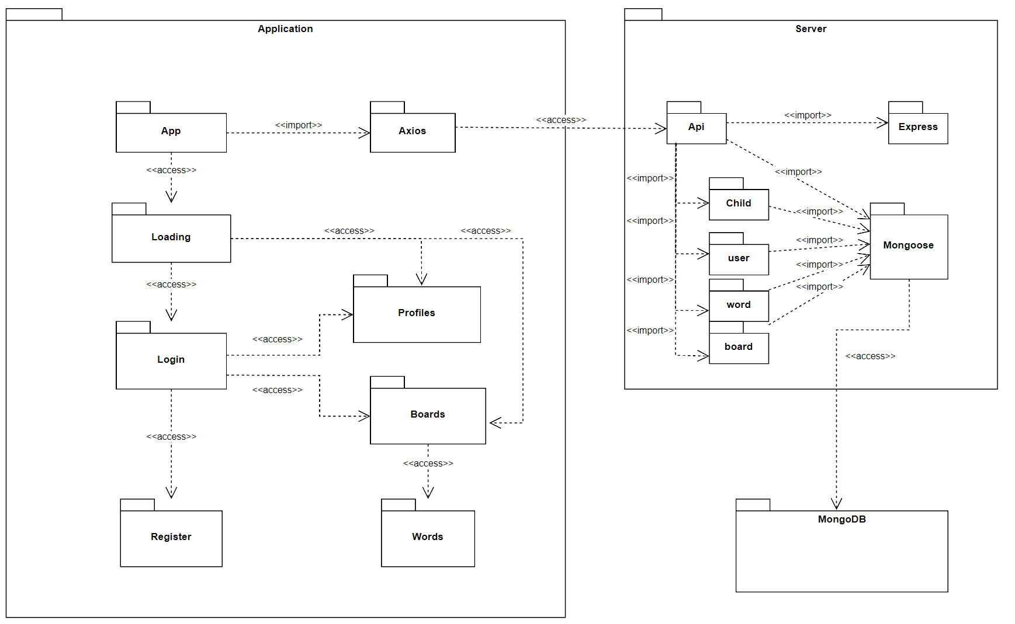

## 3.2 Activity Diagram

Child communicates through the application

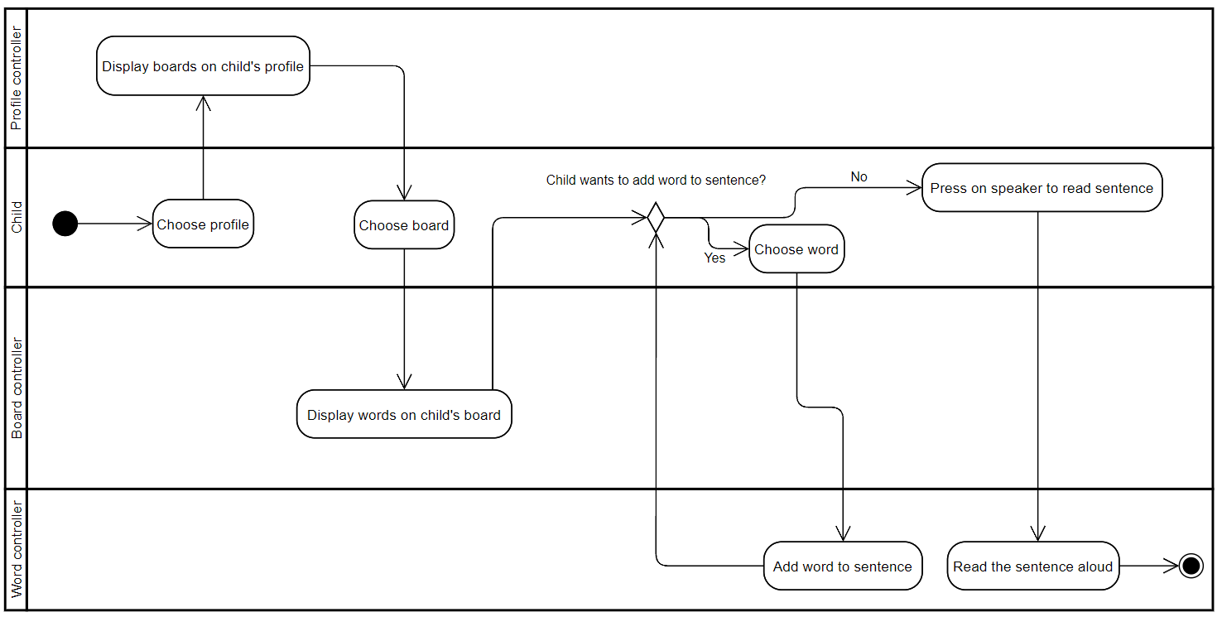

# 4. Description of the Development Process

To ensure that the suggested concept meet the user’s requirements, the development process included all stages of the Design Thinking method from User Centered Design [Nelson,1993 ] [5]:

**Define: Initial Planning and Decision Making**

Initially, our requirements were provided by Mr. Offer Gann (a person with disabilities who cooperates with Braude College), who outlined his vision for a communication board application. Subsequently, we decided to tailor our application specifically for children, prompting a need to adjust our requirements accordingly.

Mr. Gann outlined certain requirements , some of which we tailored to suit our application's primary audience: kindergarten children. For instance, he suggested a keyboard feature for sentence construction. However, given the young age of our target audience, kindergarten children, we chose to prioritize pictograms over keyboard input. This decision ensures a more intuitive and accessible user experience, aligning closely with the developmental needs and abilities of our users.

While our focus has been on optimizing the user experience for kindergarten children, it's important to highlight the adaptability of our application. We can easily adjust the features to align with Mr. Gann's original requirements. Moreover, our platform's flexibility extends beyond addressing Mr. Gann's specifications. We have the capability to implement changes that accommodate different audiences, such as adults.

We then engaged in discussions with "Eshkol Geni Yuvalim" kindergarten, where we gained firsthand experience with their current communication board application, actively used by them and other kindergartens. However, this application proved impractical for children due to its excessive screens, limited user support per device, high cost, and exclusive compatibility with iOS devices. Consequently, we sought input from the kindergarten staff to better understand their specific requirements for a child-friendly communication board application and how we could better align our solution with their needs. Enabling user profiles necessitates the implementation of a client-server architecture.

After gathering all the requirements for the "Diburnik" application, we embarked on making crucial decisions that would set the foundation for our client-server application development process.

This stage involved:

**Framework Selection**: After careful consideration, we opted for React Native as our framework. The main factor behind this decision was the requirement to support both iOS and Android devices. React Native's cross-platform capabilities offered the flexibility and efficiency needed to achieve this goal.

**Database Selection**: We evaluated various options and decided to employ MongoDB because of its combination of being cost-free indefinitely and its compatibility with Node.js.

**Backend Deployment Strategy**: We chose Node.js and Express.js for our backend deployment strategy owing to their popularity and the wide availability of educational resources.

**Database and Code Organization**: With the framework and database chosen, our focus shifted to structuring the database schema and organizing our codebase effectively. Recognizing the necessity of supporting user profiles, we developed a user schema. Anticipating the hierarchical relationship, we created a child schema for teacher-type users with multiple children. Additionally, we introduced a board schema to accommodate the various boards associated with each child, and a word schema to manage the words within these boards.

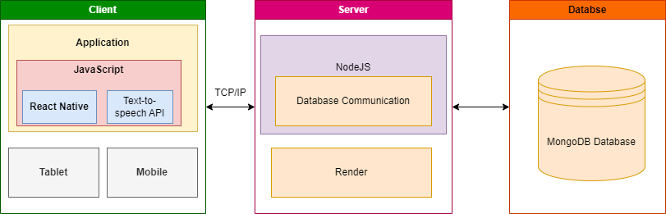

*Figure 1: System's Architecture.*

**Development: Code Implementation**

During the code development we had to learn new technologies essential for the project. This included gaining experience in React Native, JavaScript, Node.js, Express.js, how to deploy our backend and understanding the intricacies of working with APIs. Additionally, we gained hands-on experience with GitHub, collaborating on codebases through merges and pull requests. Each team member maintained their own branch, requiring us to effectively resolve conflicts that arose during the development process.

Through the application of these tools and technologies, we successfully developed an Android and iOS communication board application tailored to meet the requirements of children with complex communication needs. Our solution significantly enhances the communication abilities of the children, providing them with a more intuitive and accessible way to express themselves. Moreover, our application supports the Hebrew language and incorporates user profile functionality, enabling users to access their communication boards easily across any device. This approach ensures that our application not only addresses the diverse needs of its users but also offers a personalized and inclusive user experience.

**Prototype:**

We collaborated closely with “Eshkol Geni Yuvalim”, a kindergarten campus, located in Upper Afula. The campus is a home for children between the ages of 3 and 7 who have complex disabilities such as: cerebral palsy and /or developmental delays of varying levels.

We provided a prototype of the app to be used by kindergarten teachers, speech therapists, and the kindergarten's children. After using it, they provided us with positive feedback. They were very impressed by the prototype we developed, expressing admiration for its functionality, design, and overall effectiveness in meeting their needs. We took some remarks about the design and documented the bugs that were encountered during their trial of the prototype.

The kindergarten staff were impressed by the simplicity and intuitiveness of creating new boards and adding words to them. With just one demonstration, they quickly grasped the process and were able to replicate it independently. Their feedback underscored the superiority of our application compared to their current one.

One of the adjustments the kindergarten staff requested from us was to include text next to certain buttons. For example, labelling "+" button for adding a new board as "Add New Board" for improved user clarity.

**Evaluate and Refine: Final Code Refinement**

We incorporate the feedback we got into our refinement process. We made the necessary adjustments and improvements to ensure that our app aligns with user expectations and delivers a positive user experience

In our effort to refine the code, we tested every feature of our app, and tried to find any hidden bugs or inconsistencies. This approach ensured that our app meets the highest standards of quality and reliability.

We were also focused on identifying and removing any unused variables and functions. By carefully reviewing our code, we have eliminated any unnecessary clutter that could impact performance or introduce errors. This optimization effort is aimed at enhancing the efficiency and responsiveness of our app.

Overall, we received very positive feedback from both the kindergarten teachers and the speech therapists regarding the final product. They expressed satisfaction with the app's functionality, user interface, and its potential to support the development of communication skills in children with diverse needs. Form observation of the children using the application - they were very engaged with the application and were able to express their feelings and needs independently. Few bugs were found by the users.

We provided the kindergarten teacher therapist with a SUS (System usability scale) Query[4] to gather feedback on the usability of our application.

The filled SUS Queries can be found in ‘Appendixes’.

Additionally, we received a written review from the kindergarten teacher, Luba Schwartzman, which also can be found in ‘Appendixes’.

# 5. Challenges Faced and Solutions

# 5.1. Planning and Functional Challenges

1. **Cross-Platform Support: Multiple Operating Systems**

Given the absence of a Hebrew communication board application supporting both Android and iOS, we prioritized ensuring our system's compatibility across platforms. We chose to develop with React Native, which theoretically offers uniform functionality for both operating systems, seemed like a logical choice.

However, throughout development, we encountered many instances where the Android implementation failed to function correctly, and in some cases, entire features were non-operational on Android devices. This presented a significant challenge for us, leading to the realization that certain features would need to be tailored specifically for the Android platform, diverging from their iOS counterparts.

We also considered adding web support to broaden accessibility, but we ultimately dismissed the idea. Our implementation heavily relies on libraries and functionalities designed exclusively for mobile devices. Introducing web support would require a significant restructuring of our existing infrastructure, prompting us to abandon the notion in favor of maintaining focus on our mobile application development.

1. **Loading Time Challenges**

During the development of our project, we encountered a notable challenge: prolonged loading times, largely attributed to the extensive collection of pictures we managed. This was compounded by our reliance on a free database, which inherently imposed speed limitations. Additionally, rendering these pictures within our application consumed considerable time.

To address these hurdles, we devised two key solutions. Firstly, we developed a custom caching mechanism to expedite data retrieval after the initial load, bypassing database limitations. Secondly, we optimized image uploads by reducing resolutions and compressing files, significantly accelerating rendering times. These measures not only mitigated delays but also enhanced overall performance, ensuring a smoother user experience.

1. **Backend Deployment Timeout**

Our free backend deployment shuts down after 15 minutes of inactivity. This meant that if no actions were taken within this timeframe, the subsequent user would encounter delays as the backend had to "wake up," a process that takes several minutes. This resulted in a suboptimal user experience.

To address this issue, we implemented a solution using a cron job. We created a cron file, which executed a specified function every 14 minutes. This function triggered an HTTPS GET request to the backend, effectively keeping it alive and preventing it from shutting down due to inactivity. By proactively sending requests to the backend at regular intervals, we ensured that it remained responsive and readily available for users, minimizing delays and optimizing the overall user experience.

1. **Workflow Planning**

One challenge we encountered in our workflow planning was the difficulty in scheduling meetings due to conflicting availability among us. Each of us had different hours we could commit to meetings, making it challenging to find suitable times for everyone to convene. Consequently, this led to the need for individual work and asynchronous collaboration, resulting in occasional discrepancies in code implementation.

These discrepancies arose because without real-time collaboration, we had to work independently, sometimes leading to divergent approaches in coding solutions. As a result, when integrating individual contributions, we faced challenges in reconciling these differences, which required additional time and effort to resolve.

To tackle these challenges, we recognize the need for clearer communication and synchronized collaboration. We'll implement strategies like regular check-ins, asynchronous tools, and better documentation to smooth collaboration and improve efficiency, thus streamlining our workflow

1. **Background Color for Words**

Initially, our plan was to enable our system to automatically detect the part of speech when adding a new word. Subsequently, all words of the same part of speech would be assigned a uniform background color.

While we successfully implemented this feature, we later realized its limitations. In certain instances, multiple words of the same part of speech can appear within a single sentence, rendering the classification inadequate.

During discussions with the kindergarten team, we observed that classification could serve purposes beyond sentence construction. It could also aid in teaching children about word rhyming. As a result, we opted to provide users with the flexibility to manually assign background colors to words according to their preferences.

# 5.2. Aesthetics and Design Challenges

1. **Appropriate Pictograms**

In our search for suitable pictograms for communication boards, we encountered a common trend among existing solutions: they predominantly utilized a standardized set of pictograms. This realization rendered our initial approach of uploading images from device photo libraries impractical.

After extensive research, we identified an API specializing in pictograms, which notably supported Hebrew—a crucial requirement for our application. Recognizing its compatibility and suitability, we made the decision to integrate this API into our system. By leveraging this specialized resource, we ensured the provision of more appropriate pictograms tailored to our users' needs, surpassing the limitations of generic image uploads.

1. **UI Optimising for Various Resolutions**

When designing the interface for our application, we often faced inconsistencies. What looked polished on one device might appear misaligned, oversized, undersized, or otherwise flawed on another. These variations weren't limited to different operating systems but also occurred on devices with the same OS but varying screen sizes. We implemented a solution that dynamically adjusts element sizes and positions based on screen resolution. This approach ensures that the interface is optimized for every device, offering a seamless user experience.

# 6. Results and Conclusions

## 6.1. Goals Achievements

Our mission was to design and develop an augmentative communication board application that will allow children with different levels of CCN (Complex Communication Needs) to communicate more effectively and independently.

We developed “Diburnik'' to be compatible with both tablets and smartphones, supporting iOS and Android platforms, making it available for its users on a wide range of devices, ensuring accessibility wherever they go.

We also focused on creating a user-friendly interface that will be intuitive for all users, particularly prioritizing children with CCN.

By prioritizing simplicity and intuitiveness, we aimed to empower users to effectively utilize the application's features and enhance communication with their experiences.

To measure the success of our project, we defined during the design process the following 3 key criteria for success:

1. **Effective Communication and Independence**: We aimed to enhance the children's ability to communicate effectively with their surroundings independently through the utilization of our application.
2. **Long-term Impact**: Our goal was to create a solution with enduring benefits, positively influencing the child's development beyond their immediate engagement with the application.
3. **User Satisfaction**: Feedback from both the child and the adult users should indicate a high level of satisfaction with the application, including its usability, features, and overall experience.

We provided the application for trial use by the kindergarten teachers, speech therapists, and the children of “Eshkol Geni Yuvalim”.

One particularly lauded feature was the ability for teachers and speech therapists to assign children's profiles to their own profile and be able to easily switch between the user profiles. We got feedback that the functionality was hailed as incredibly convenient and timesaving.

Moreover, the process of creating and editing new boards within the application was met with great satisfaction.

According to the kindergarten teacher's observations while using the application with the children, the children were very engaged and excited about the new application. They were able to express their needs and wants and to communicate with the kindergarten staff.

## 6.2. Conclusion

## In conclusion, we came up with a final cross-platform application of a communication board that was designed especially for children with CCN in mind. The overall feedback from the end users - “Eskol gani Yuvalim” kindergarteners, speech therapist and most importantly - the kindergarten children, was very positive.

## As the development team, we faced challenges in both planning the product and in the implementation itself - learning together new technologic, scheduling the workflow, bug fixing , challenges, making prioritizations (challenges described more widely in ‘Challenges Faced and Solutions’ section of the project book).

## We overall managed decision making very well as a team, had great teamwork and were very open minded. We could plan our work better in terms of saving time waste - there was one feature that we developed not as we originally planned, and we had to redo the code, which was time consuming and caused few problems and bugs when trying to remove the old implementation.

## We are very glad about the final outcome of "Diburnik." Not only from the application's final outcome but also from the process that led to its creation.

## Ultimately, we believe that the application has the potential to significantly enhance the communication abilities of the children and support their overall development, and so meet the goal of long-term impact of the children’s development - which will be the most important achievement and success for us.

## 

Looking back on our project, one decision we would have approached differently is how we tackled the development of the UI. While we initially opted to build the UI from scratch to adhere to our original plan, we now recognize the benefits of utilizing premade UI libraries in React Native. This alternative approach would have not only alleviated the challenges we faced during UI development but also freed up valuable time and resources. With a solid foundation in place, we could have focused our efforts on enhancing functionality and delivering a more comprehensive application experience.

## 6.3. Future Work

Our roadmap for the future involves enhancing and expanding our application by:

* **Customize Voices:**

Currently, our application utilizes the voice of the device's personal assistant. However, this limits our ability to distinguish the appropriate voice type for the user. We aim to implement a feature that assigns a male voice for male users and a female voice for female users. Additionally, we seek to provide options for both adult and child voices to better accommodate diverse user preferences.

* **Expanding target audience:**

Our application is currently designed with children in mind. However, with minor adjustments, we could modify it to suit adults as well. Looking ahead, we envision implementing distinct user interfaces based on user type to better meet the preferences and needs of both children and adults. This includes tailoring visuals and interactions to be age-appropriate for each demographic.

* **Language Support:**

Currently, our application exclusively supports Hebrew, both for word search and voice functionality. However, we are considering expanding language support to include additional languages in the future.

# 7. User Documentation

## 7.1. User Guide

### 7.1.1. General Description

“Diburnik” is an augmented communication application that is dedicated to helping children with special communication needs to express their thoughts, feelings and needs. “Duburnik” provides a convenient platform for children to express themselves confidently and autonomously.

The application was designed with a simple user interface, vibrant colors and intuitive navigation, especially for children with special communication needs in mind. Compatible with both Android and iOS platforms, “Duburnik” is available for both tablets and smartphones, ensuring accessibility anytime, anywhere.

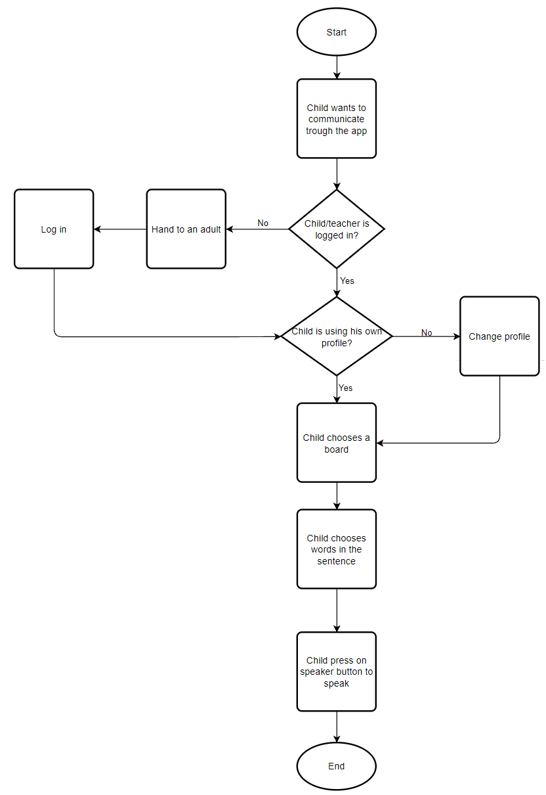

### 7.1.2. Operating Instructions

To start, ensure that your device has a Hebrew Text-To-Speech engine. iOS devices typically come with one pre-installed. For Android devices, navigate to the Text-To-Speech (TTS) settings and verify Hebrew is installed and activated. If Hebrew isn't available, download a compatible Text-To-Speech engine from your device’s app store.

In the upcoming section, we will provide you with a comprehensive User Guide on how to use the “Duburnik” application, after you have successfully managed to install it.

1. **‘Login’ Screen**

To access your account, simply enter your username and password in the fields provided on the ‘Login’ screen. New users can click the registration link to create an account.

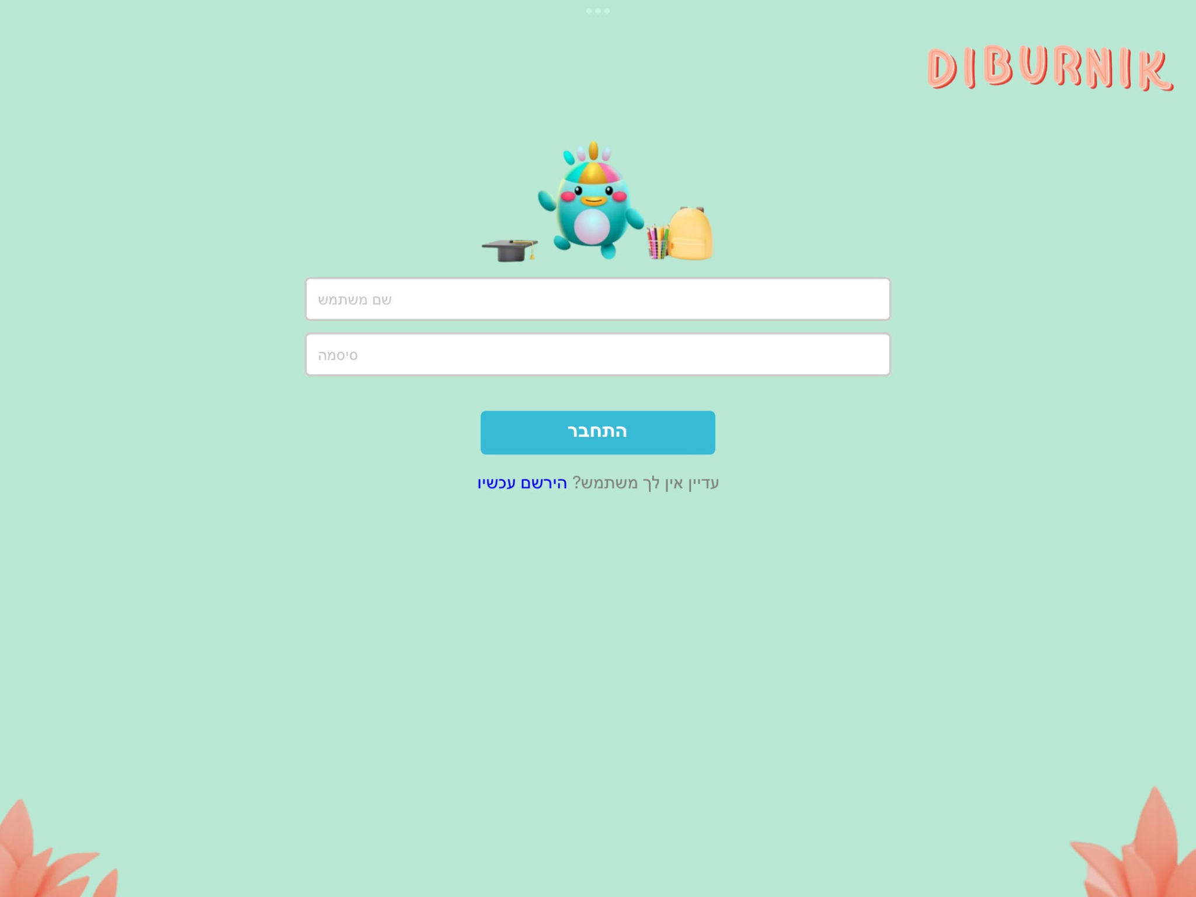

1. **‘Registration’ Screen**

Registration requires completion of essential fields: Username, Password, and Email Address.

When creating a new account, specify the user type is needed: (1) Teacher or (2) Child. If you select 'Child,' you also have the option to upload a profile picture from your local device.

Once all of the required data is filled in, press the 'Register' button to complete the registration process.

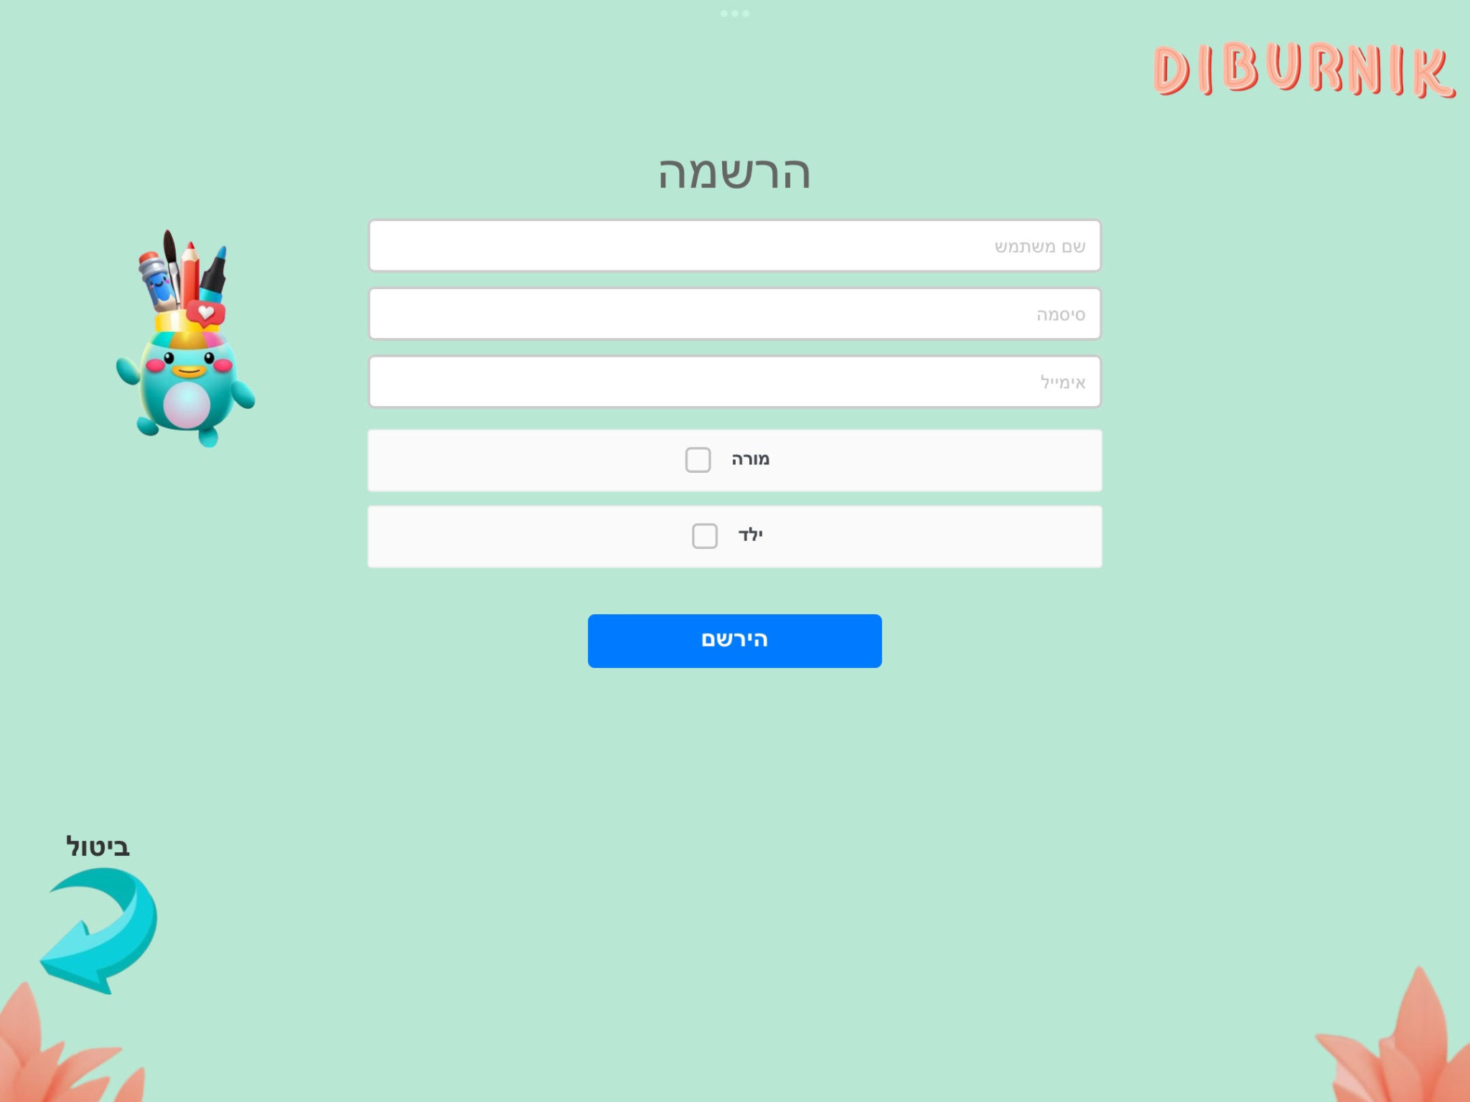

1. **‘Profile Selection’ Screen**

Upon logging in, there is a different landing screen for kindergarten teachers’ users and child users.

For teacher users, the landing page presents a dashboard displaying all of the children's profiles that were associated with their user account previously. This screen offers a convenient way for the teacher to switch between the children's profiles.

Clicking on a child's profile grants access to the child’s communication board for viewing, creating, and editing if needed.

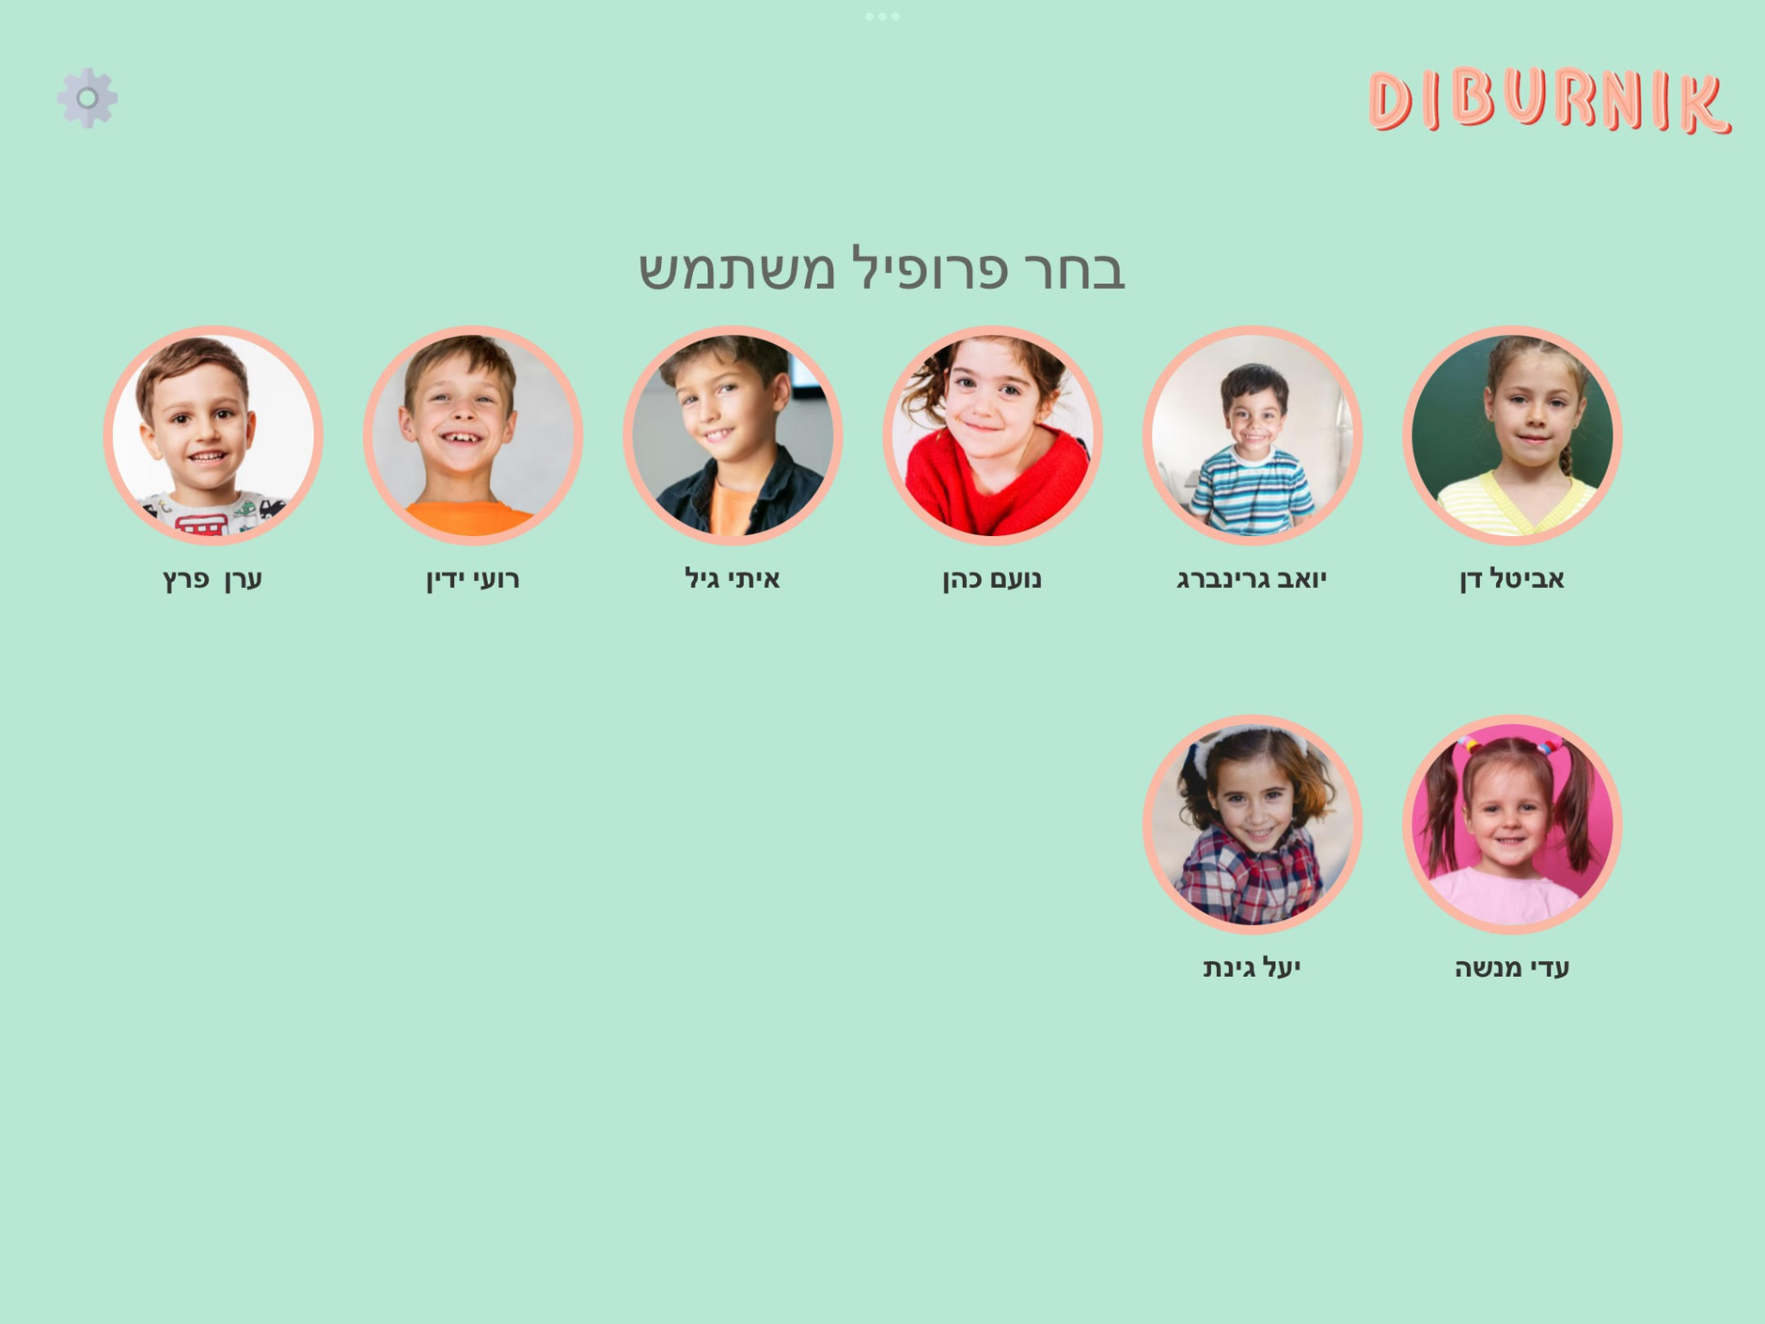

1. **Adding / Removing Child’s Profile**

To initiate editing, access the 'Edit Mode' by tapping the 'Settings' icon located at the top left corner of the screen, and then select the "Enter Into Edit Mode" option.

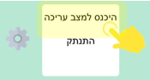

Entering into ‘Edit Mode’ in the profiles screen allows the user (kindergarten teacher) to edit children's profiles, remove child profile from the profile’s dashboard (clicking on “X” button) , or assign a new child profile to their profiles dashboard.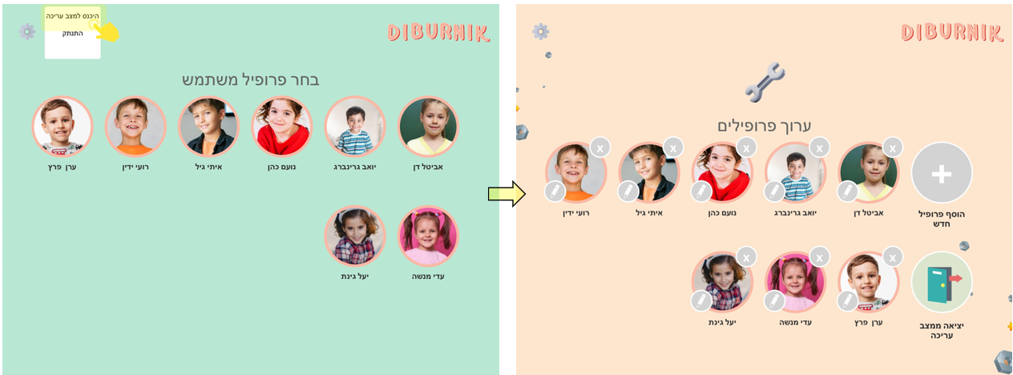

To exit ‘Edit Mode’ , press on the “Exit From Edit Mode” button.



Adding a new children profile to the user’s profiles dashboard is done by pressing on the “Add New User Profile” button. To add a new child, the adding user must know either the child’s username or email.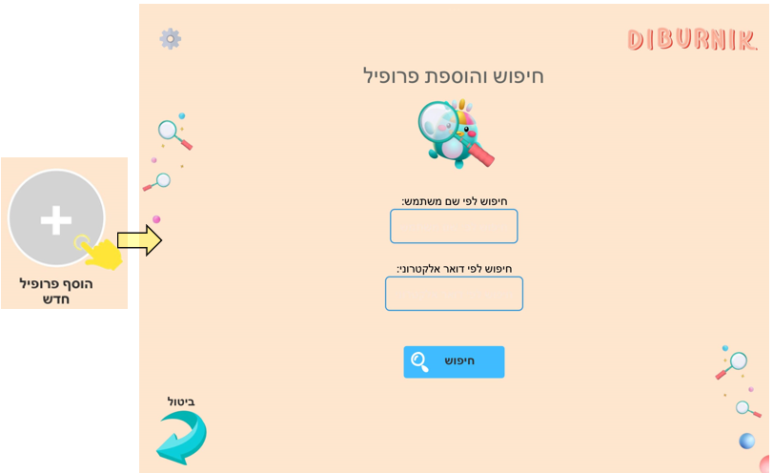

1. **‘Communication Boards’ Screen**

The communication board screen displays a list of communication boards that were created and customized (by parents/ therapists) tailored to each child's unique needs and interests.

Each board has a representing picture and a title. Clicking on a board opens it for view and use.

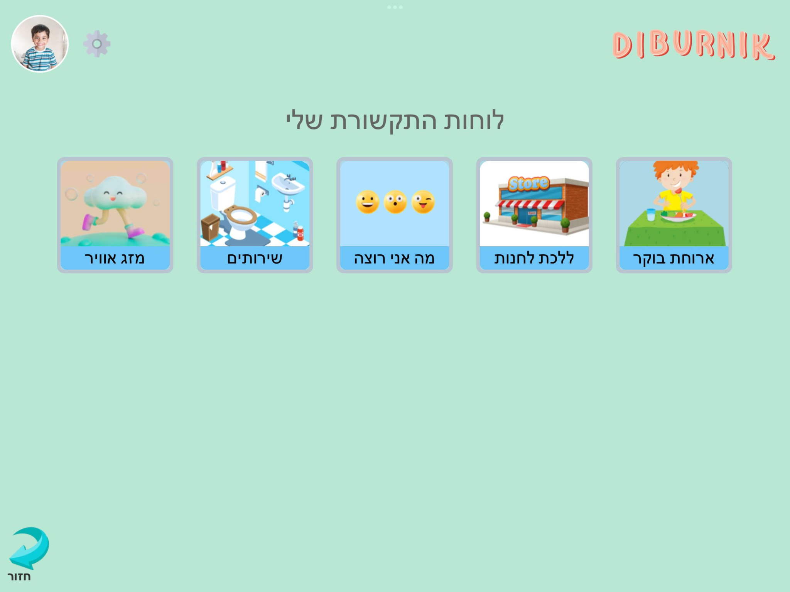

1. **‘Add A New Communication Board’ Screen**

The application allows to add any needed amount of communication boards.

To add a new communication, navigate to the 'Communication Boards' screen and tap the "Settings" icon at the top left corner. Then, select the "Enter Edit Mode" option.

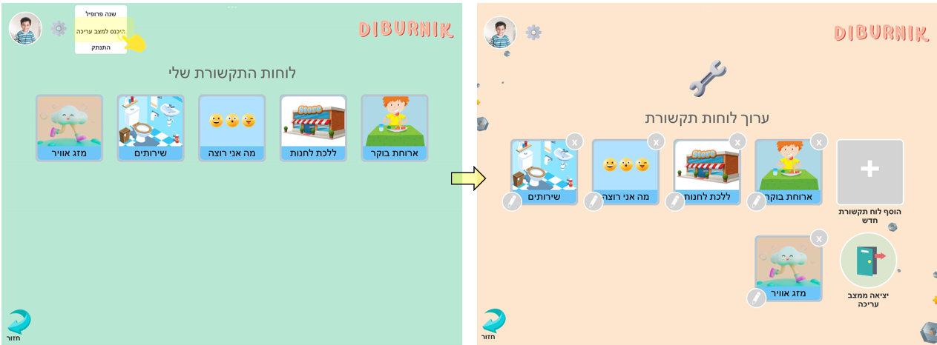

To create a new communication board, the user should press the "Add New Communication Board" button. To save the board, the user must provide a title of the board and may also include a theme picture from the internal storage of their device.

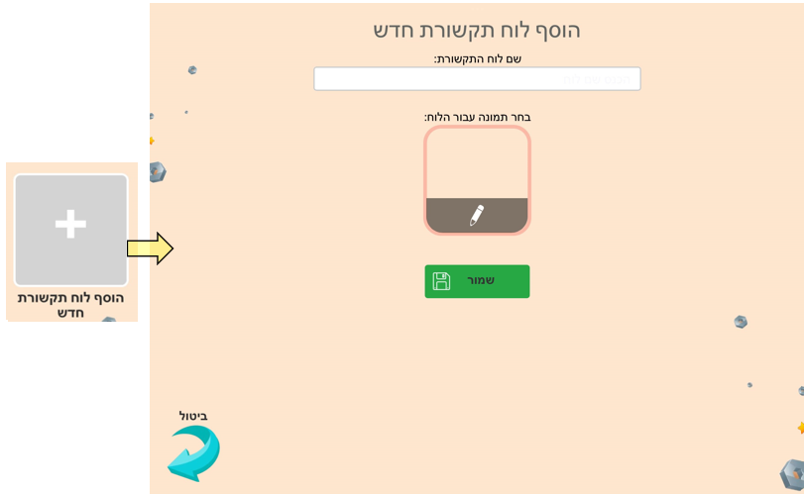

There is also an option to **remove** a communication board from the child’s profile. This can be simply done by tapping on the "X" button next to the communication board you wish to remove.

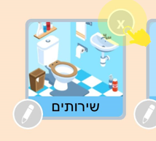

To **edit** a communication board, press on the “Edit” button (pen icon) that appears next to the communication board you wish to edit.

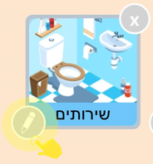

1. **‘Words’ Screen**

The ‘Words’ screen of the communication board displays words and phrases categorized by colors for easy selection.

The child needs to select words from the communication board to construct a sentence. Each word press triggers its pronunciation. Pressing on the megaphone button plays the pronunciation of the complete composed sentence.

When constructing a board, words with similar meanings or belonging to the same semantic group are grouped together and assigned the same background color. This color-coding helps users quickly identify related words and aids in navigation and organization on the board.

Pressing the 'X' button deletes the entire sentence that the child has constructed.

Consistently pressing a word in the composed sentence row deletes that specific word from the sentence.

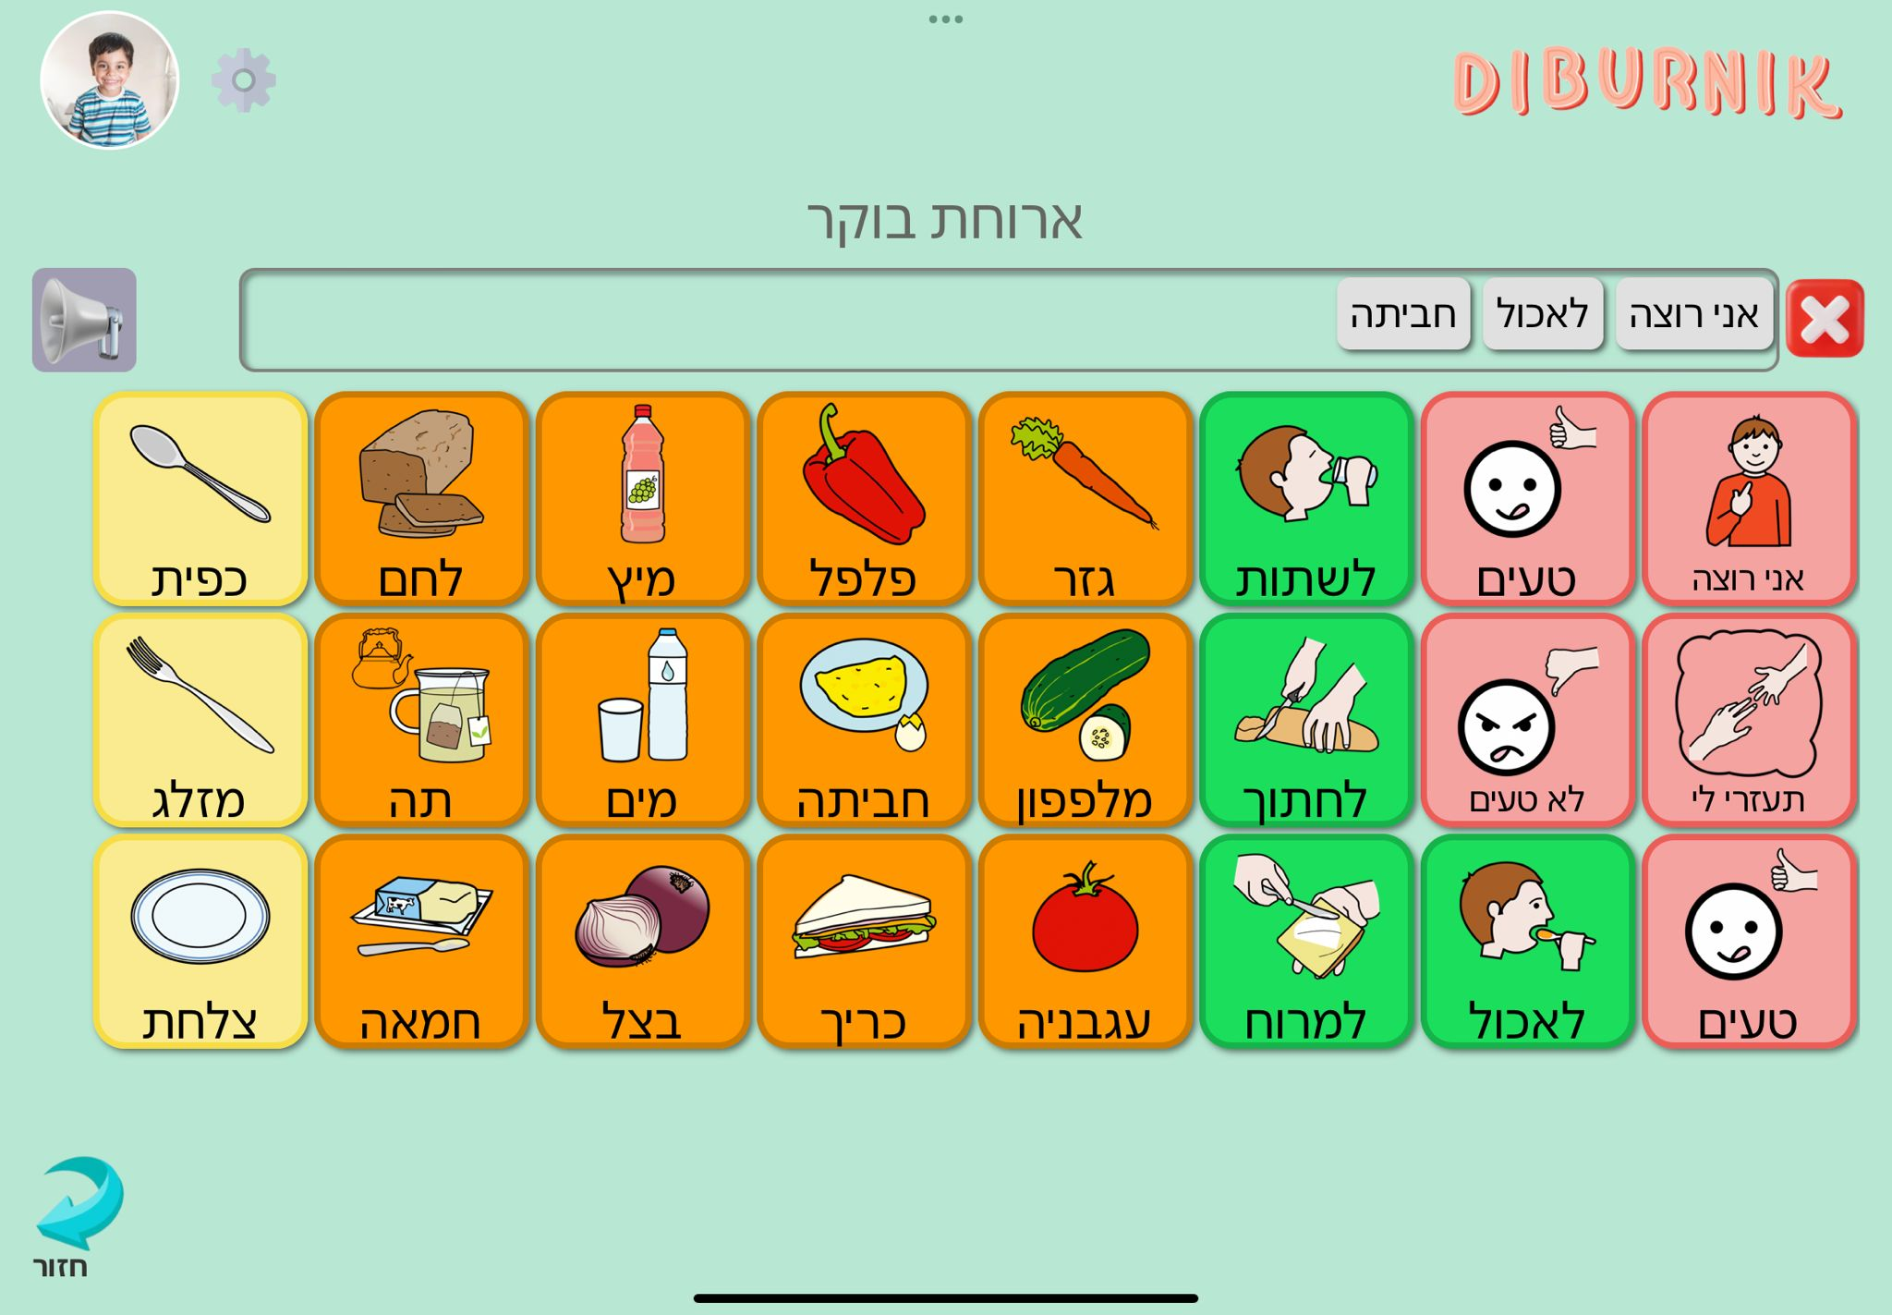

1. **‘Edit the Board Words’ screen**

To edit the communication board words, press the settings icon, then select "Enter into edit mode". You can delete words by checking the checkbox next to the desired ones and pressing on the trash button. To add new words, simply press the '+' button.

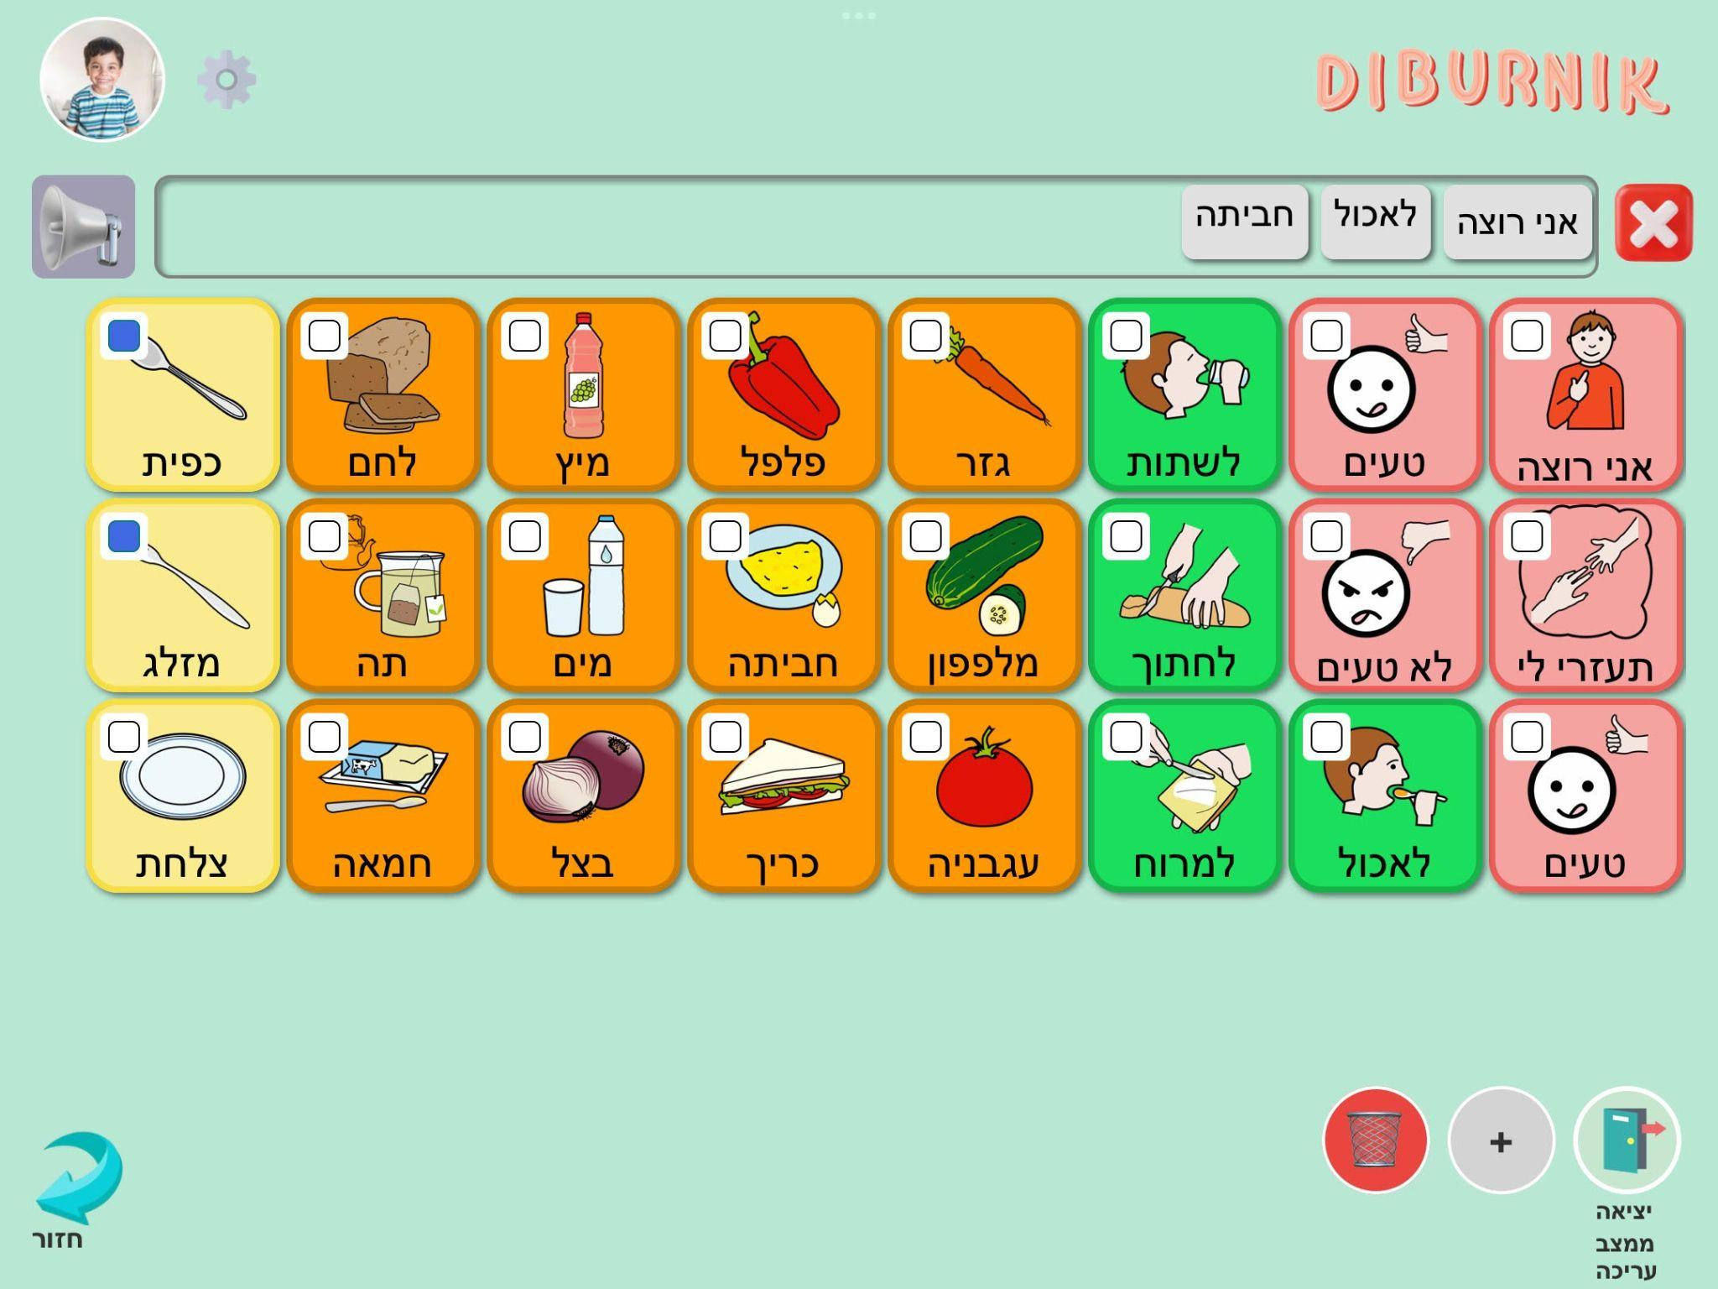

1. **Add new word to the communication board**

After pressing on the "+" button on the 'Words' screen, enter in the search field the word you wish to add to the communication board. Then, press the "search" button.

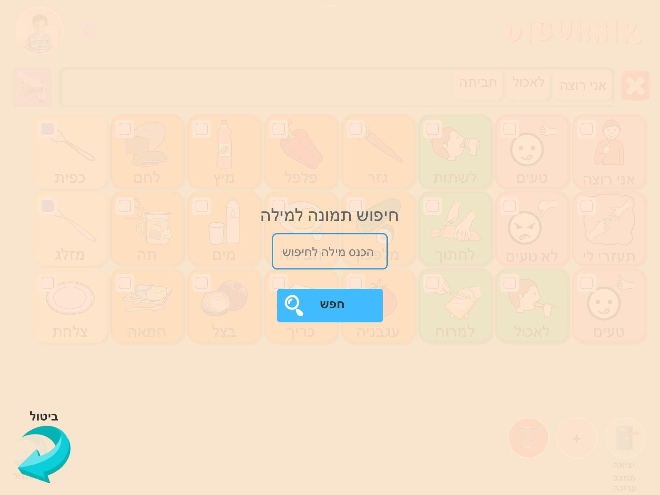

The page will display a selection of symbolic images from a collection of symbols that were created especially for communication board purposes.

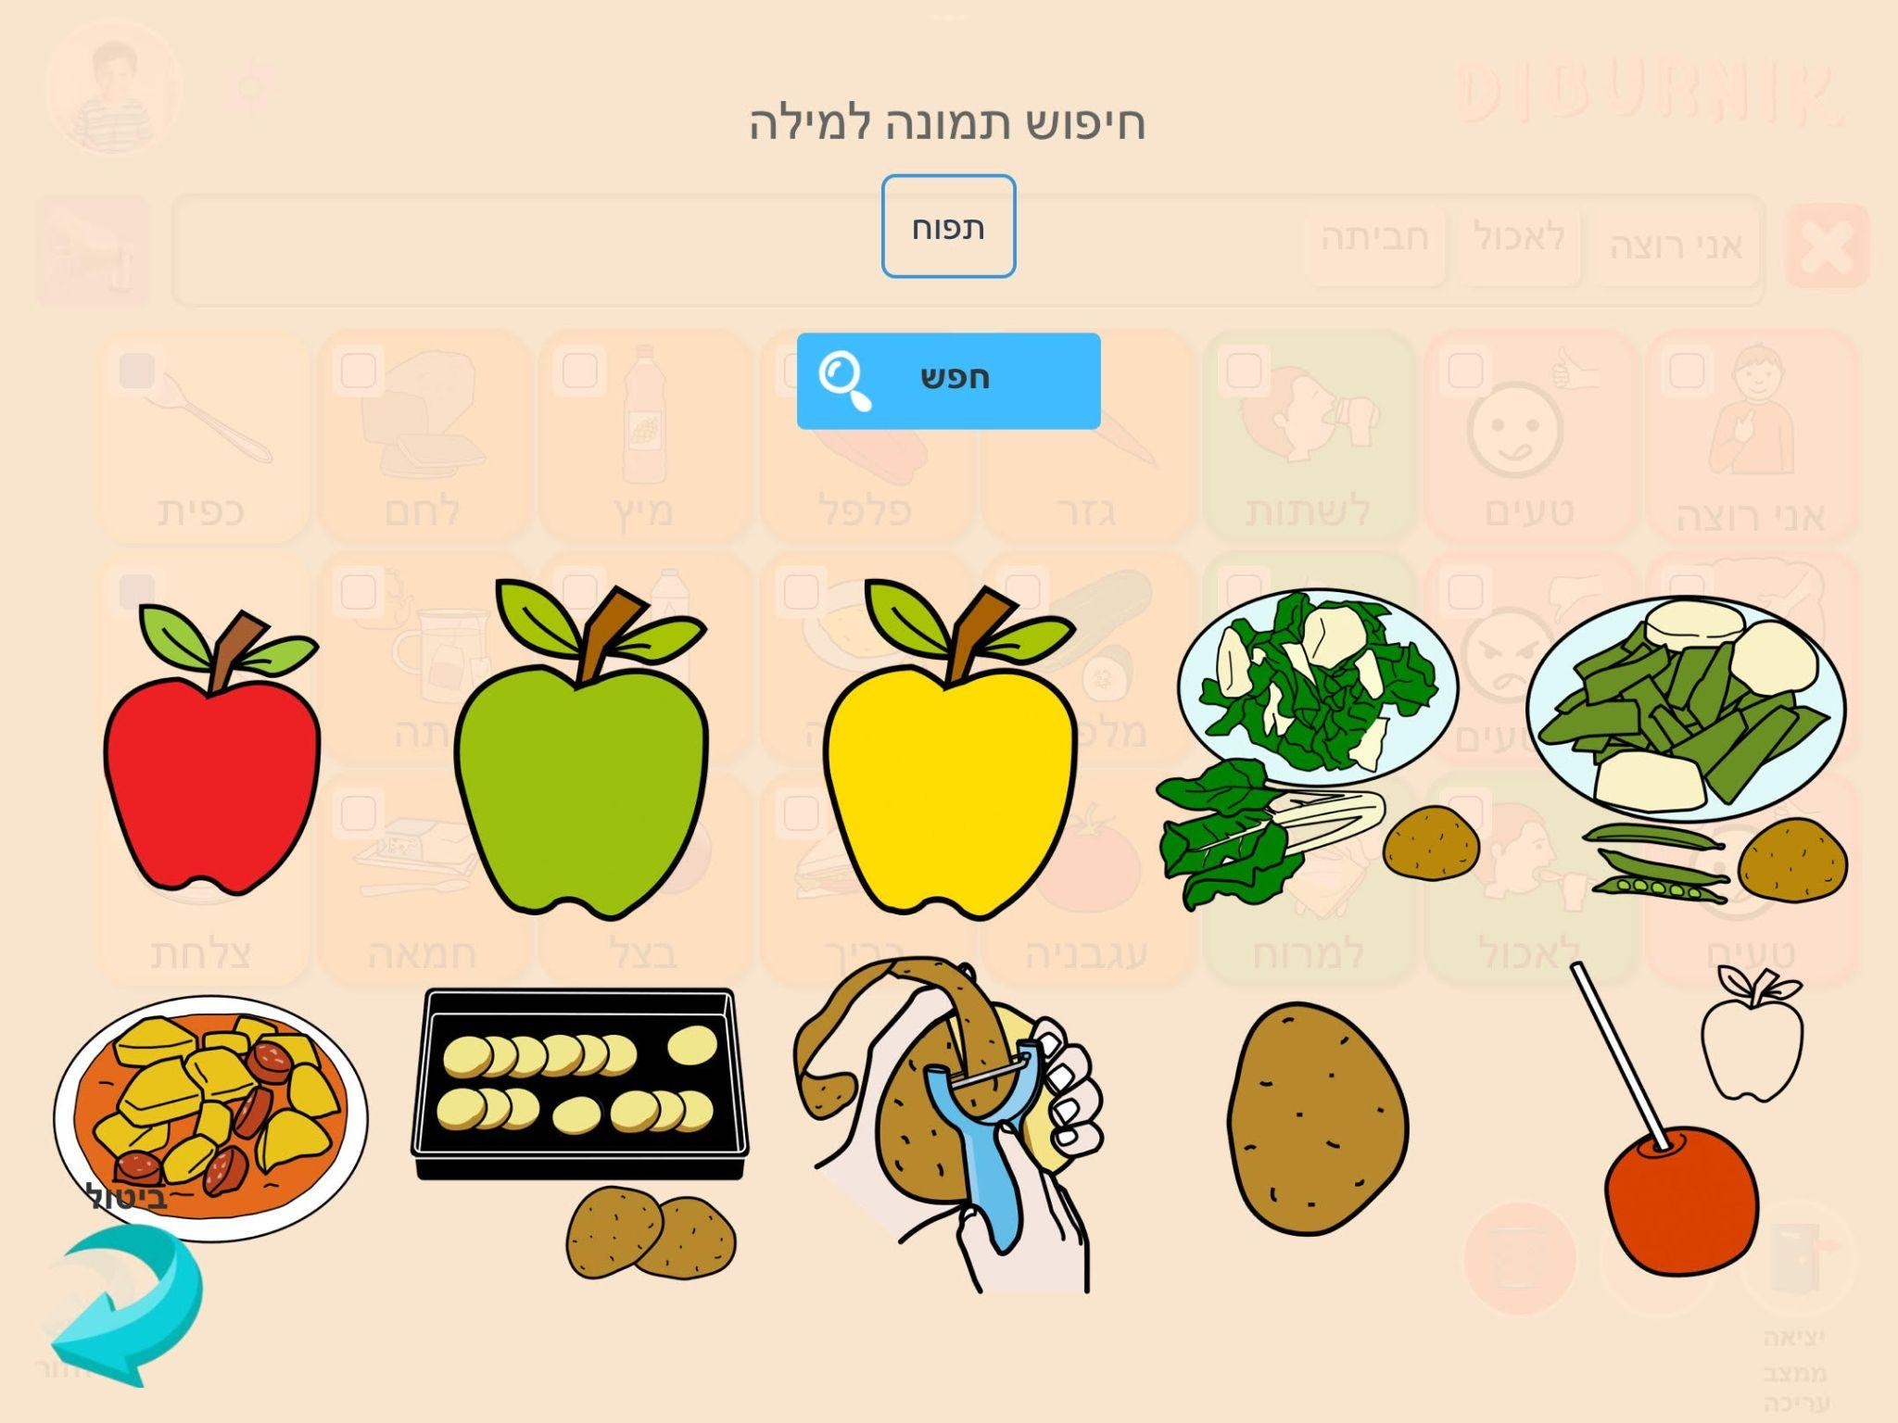

From the available symbols, select the symbol you desire by pressing on it.

You can also choose a background color for the word by simply pressing on the desired color from the available colors options. Once you've made your selections, press the "Add Word" button to finish adding the word to the board.

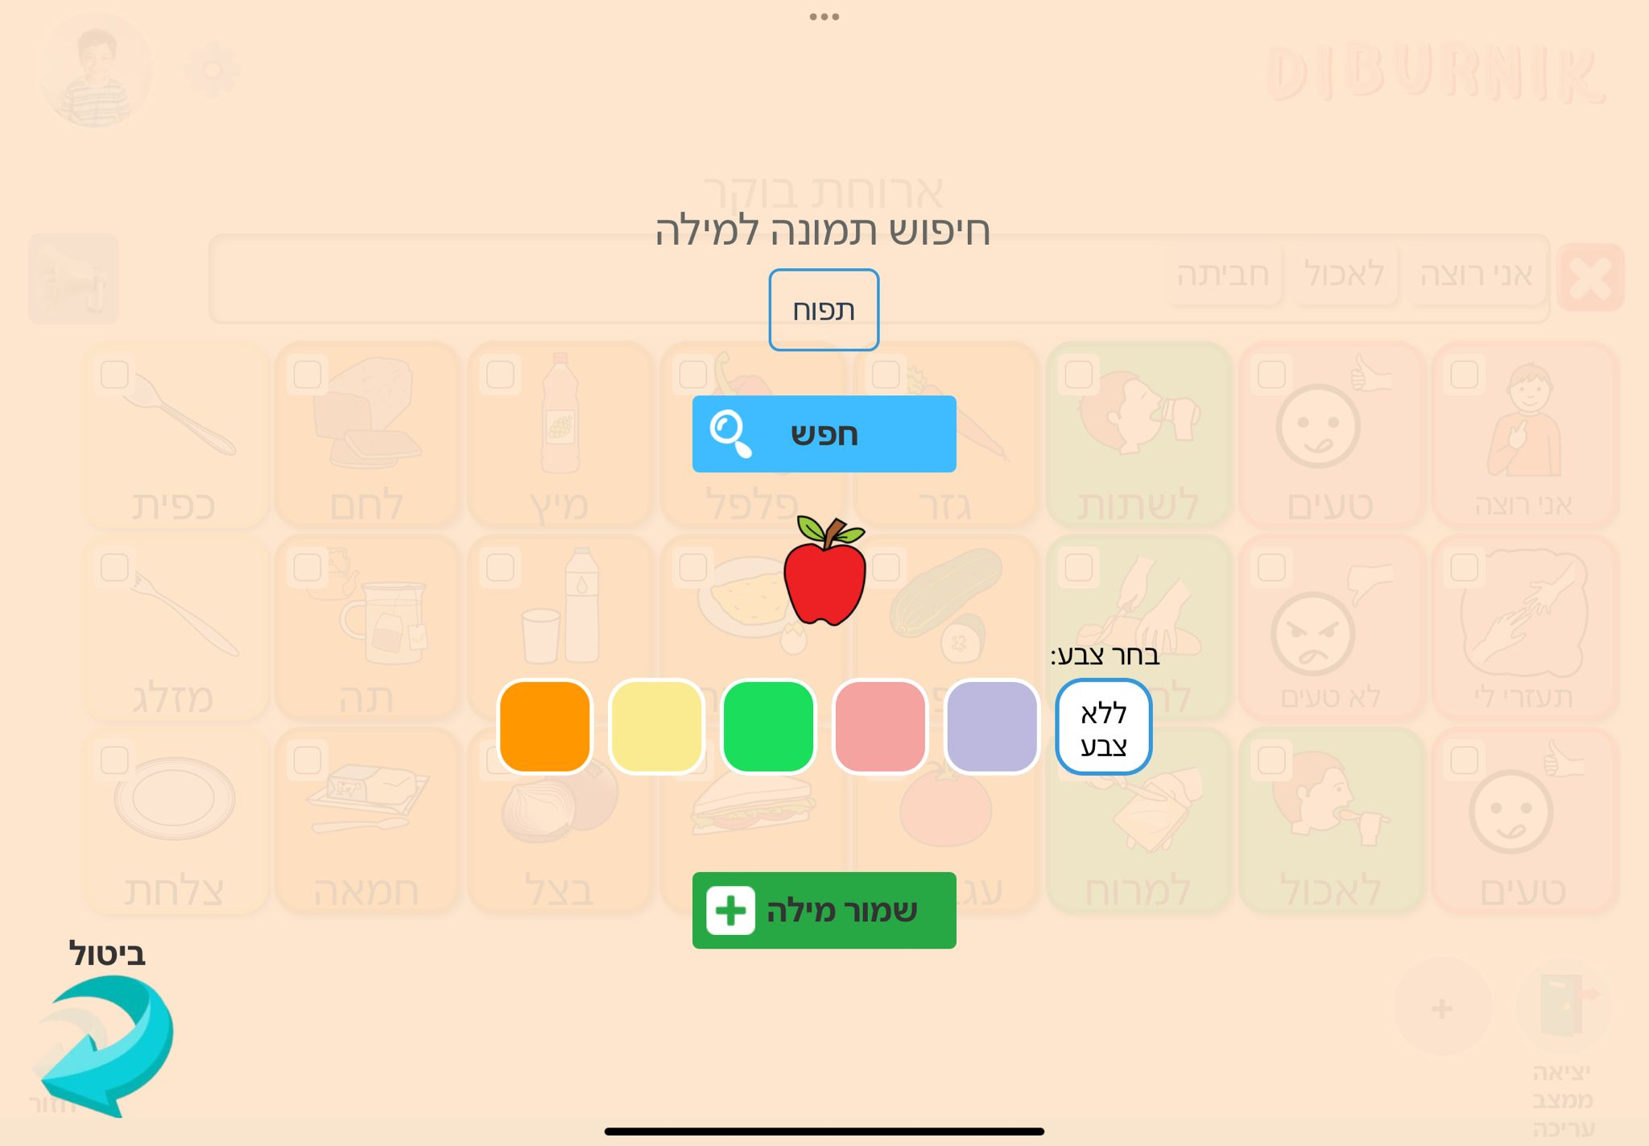

## 7.2. Maintenance Guide

### 7.2.1. Application Maintenance Guide

To maintain the application’s code, it's essential to set up specific tools and working environments on your computer and on your tablet device.

**On your computer :**

1. VSCode - [Install VSCode](https://code.visualstudio.com/Download)
2. Node.js - [Install Node.js](https://nodejs.org/en)
3. Download the code: Fetch the code’s main branch from <https://github.com/sharonSniti/FinalProject>
4. Open the terminal in VSCode and navigate to the 'frontend' directory using the command: ' cd \Diburnik\frontend '
5. In the terminal run the command: ‘ npm -i ’
6. Run the application using expo with the command ‘ npm start ’

**On your tablet device:**

1. Download and install Expo Go from your device's application store:

[](https://apps.apple.com/us/app/expo-go/id982107779) [](https://play.google.com/store/apps/details?id=host.exp.exponent&hl=en&gl=US)

1. Scan the QR code that appears on the screen with your device.

### 7.2.2. Database Structure

We chose MongoDB as our database solution due to its user-friendly interface, seamless compatibility with Node.js and because it is free of charge.

Our database tables:

1. Users

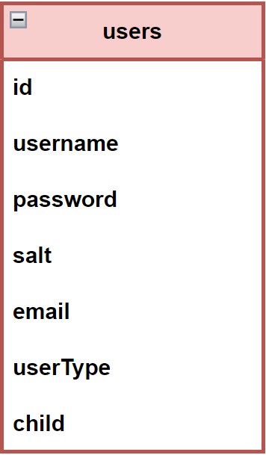

The users table serves as a repository for registered users' information, facilitating user management and authentication within the system. It stores essential details such as user identifiers, login credentials, user roles, and identifies which children are linked with this user, enabling the user's access to those children.

1. Children

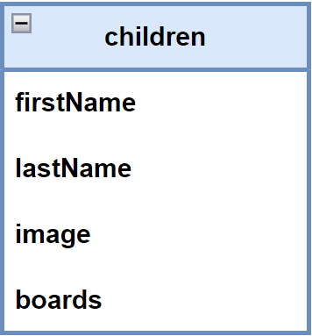

The children table serves as a repository for information about individual children within the system. It stores details such as first name, last name, and profile picture. Each child in the system is also associated with his boards, which are stored in an array. These boards represent communication boards tailored to each child's needs and preferences, providing personalized support and interaction opportunities.

1. Boards

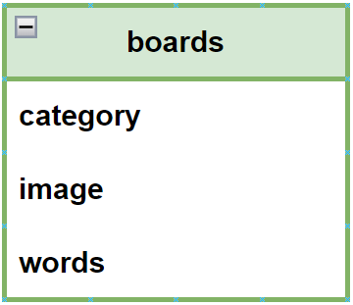

The boards table serves as a repository for communication boards within the system. It stores information such as the category of the board, the board's image, and a collection of words associated with the board.

1. Words:

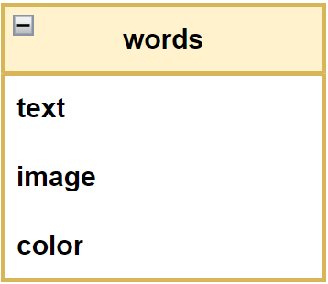

The words table serves as a repository for individual words used within communication boards in the system. It stores details such as the text of the word, an optional image associated with the word, and the color assigned to the word for display purposes in the user interface.

### 

### 7.2.3. Use Case Diagram

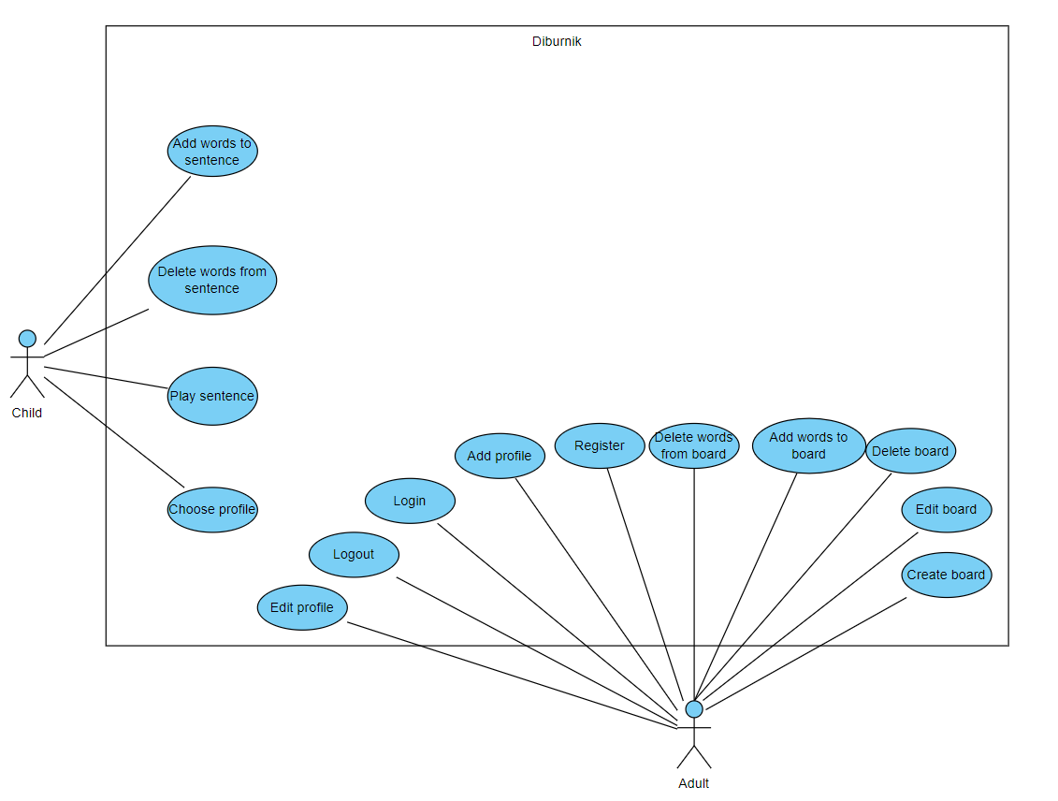

# 8. References

# 

**1.** <https://en.wikipedia.org/wiki/Augmentative_and_alternative_communication>

**2.**

Baxter, S., Enderby, P., Evans, P., & Judge, S. (2012). Barriers and facilitators to the use of high‐technology augmentative and alternative communication devices: a systematic review and qualitative synthesis. International Journal of Language & Communication Disorders, 47(2), 115-129.‏

<https://onlinelibrary.wiley.com/doi/pdf/10.1111/j.1460-6984.2011.00090.x?casa_token=MBj0YPhEPRoAAAAA:AkytHfKYdOBF9vrMClMR9Dap8KNG2xepdmDW0fO3sOWrB7soyFrX2lVN881ePHOXGjTesm0tVOHDRNo>

**3.**

Pereira, J.A., Pereira, J.A., & Fidalgo, R.N. (2021 ). Caregivers Acceptance of Using Semantic Communication Boards for Teaching Children with Complex Communication Needs. Centro de Informática - Universidade Federal de Pernambuco (UFPE), Recife, PE, Brazil.

<https://sol.sbc.org.br/index.php/sbie/article/view/18094/17928>

**4.**

[Brooke, J. (1995). SUS - A quick and dirty usability scale.](https://en.wikipedia.org/wiki/System_usability_scale)

**5.**

Nielsen, J. (1993). Usability Engineering. London, England: Academic Press.

# 9. Appendixes

